**Department of Computer Science**

**BSCS(Hons)**

**PROJECT Report**

**ON**

**LIBRARY MANAGEMENT SYSTEM**

Submitted to

**Ma’am Asma Kanwal**

Department of Computer Science

GC University, Lahore

Submitted by

0250-BSCS-18 alishuja519@gmail.com

Section

E2



Contents

**Abstract:** 3

**Introduction:** 3

**Statement of Problem:** 3

**Aim of this Project:** 3

**Purpose of this Project:** 4

**Scope of this project:** 4

**Objective:** 4

**Functional Requirements:** 4

**Non-Functional Requirements:** 4

**Software Requirements:** 5

**Programing Language:** 5

**User of System:** 5

**Modules Description** 5

**System Requirements:** 7

**Admin Login**: 7

**Student Login:** 7

**Add New Book:** 8

**View All Book:** 8

**Add students:** 9

**View All Students:** 9

**Issue Book:** 9

**Implementation Requirements:** 10

**Hardware Support:** 10

**Software Support:** 10

**DataBase Design** 10

**System Design** 12

**System testing:** 16

**Summary:** 16

**Conclusion:** 16

# **Abstract:**

In my project, on “**Library Management System**”, I tried to show how information is managed in the library. This project is just an overview of management in the library. My project is divided into various modules. My project has the ability to show accessible book information in various departments. The project has many features which are generally not available in normal library management system like facility of admin login and a facility of student login through which they can monitor the whole system. It also has a facility where students or admin after logging in their accounts can add books, viewbooks by name or by author name, and issue book as well also add new students and view all students as well. I have included only a few modules, as my purpose is to only have the idea or study how the management is done in the library by using a database system. Many further modules can be added to it.

# **Introduction:**

Library Management system is a software used to manages the catalog of the library. This helps to keep the records of the whole transaction of the books available in the library. The Library Management System is a Library Management software for monitoring and controlling the transaction in a library (Ashutosh and Ashish, 2012).The library management System helps the library to keep control of all its books and to control its members. This project aims to develop a library management system to make it easier and more efficient. The management system of the library allows a fully automated library service. It has the ability to show accessible book information in various departments. The project has many features which are generally not available in normal library management system like facility of admin login and a facility of student login through which they can monitor the whole system. It also has a facility where students or admin after logging in their accounts can add books, viewbooks by name or by author name, and issue book as well also add new students and view all students as well. Overall the main purpose of my project is to help the students and to maintain the library in the best way and also reduce human efforts.

# **Statement of Problem:**

The existing system is very traditional and manual. They are recorded using a pen-paper system due to which a lot of time is wasted. It is difficult to trace a book and information about the issue or return of the book is not properly maintained. The drawback of the existing system include mismanagement and unreliability.

# **Aim of this Project:**

The main aim of this project is to build up a framework that can deal with the activities associated with a library in a proficient and reliable manner.

# **Purpose of this Project:**

The purpose of this project is to provide a family environment to maintain the details of the book and library members and the fundamental reason for this project is to build up an automated system that will deal with the activities in the library.

# **Scope of this project:**

This project is basically updating the manual library system into the software-based application so that the user can know the details of the books and the students. This system has different types of forms that are used for input, manipulation, and output of data. This system will be tested for the usability, functionality, reliability, and performance of the application as a whole and its parts.

# **Objective:**

Library Management System is a term for a PC based system that deals with the inventory of a library. The principle motivation behind this system is to oversee the library everyday activity proficiently. In this System**,** only **admin** can add student and book and also view all book information, and **Students** can only view and issue books. This system will also store all books and member information consisting of book numbers, book author name, book publishing name, book buy date, and book quantity. It also provides a search function to help students find the book by book name or by author name. Search function will search through the book Info database to look for the book and view where the book is situated. It will help to improve the library services and increase the rate of accurate completion of the task. A system that can receive input and generate automatically output in an easy way and short time.

# **Functional Requirements:**

* Admin can log in and access the required information.
* Admin can add the books on the library shelf.
* Admin can add new student
* Students can log in and access the required information.
* Students can view all books.
* Student can issue the books
* This system also searches the books if it is available or not.
* This must have the capacity to access database problem information.

# **Non-Functional Requirements:**

* The performance of our system is fast and accurate.
* This System can handle expected and non-expected errors in ways that prevent loss.
* This System is able to handle large amounts of data, thus it can accommodate a high number of books and users without any fault.
* This system will use a secured database.

# **Software Requirements:**

The MYSQL-MYSQL database is used as a database because it is quick to manage and access information with basic queries that are easily understandable and easy to write in English.

## **Programing Language:**

**C sharp** is used to write the whole code and in C sharp, **window form** is a Graphical user interface **(GUI)** class library that is included in the .Net framework. The primary aim is to provide a simpler framework to build PC and Desktop applications. Window Forms applications can include various types of controls which are buttons, data grid view, labels, Text boxes, menu strip, etc.

# **User of System:**

* Admin
* Student

# **Modules Description**

The Library Management System is split into the following modules.

* **Admin Module:**

**Admin**



**Admin Login** **Book details** **Student Details**



**Add Student View Students**

The Following module contains different services like admin login, having book details, and student details.

* **Student Module:**

**Student**



**Student login** **Book Details** 



**View books** **Issue Book**

The Following module contains different services like student login, having book details, viewbooks and issue books.

* **Book Transaction Module:**

**Book Transaction**





**Add Book**  **View Book**  **Issue Book**

The Following module contains different services like add book, viewbook and issue book.

# **System Requirements:**

## **Admin Login**:

The admin uses this function to sign into the system. You are expected to enter the admin username and password before you are able to access the system, here is the condition where the username or password will be checked and if the username or password is incorrect the admin will not be allowed to enter into the system.

**Data Flow Diagram: Correct**



**Select Admin Login Enter Username Check username** 

**User Form or Password or password**

**Incorrect**

**Enter into System** 

## **Student Login:**

The student uses this function to sign into the system. You are expected to enter the student username and password before you are able to access the system, here is the condition where the username or password will be checked and if the username or password is incorrect the student will not be allowed to enter into the system.

**Data Flow Diagram: Student login form** 



**Select Student Login Enter Username Check username** 

**User Form or Password or password**

**Student DataBase**

**Enter into the**

**System**

## **Add New Book:**

After the login Form Admin Library Form will appear there will be an option of the add book where you can add new book information like book name, author name, book publication date, book quantity etc.

## **View All Book:**

After the login Form Student Library Form will appear there will be an option of the view all books. We can view all books based on book name or by author name. The program must be able to view the database on the basis of the **select** view type. This system must be able to show all the books in the Data grid view. **Book name**



**Login form** **Student Library** **Books Details** **View All Books** **Search Books**



**Data Flow Diagram Author Name** 

**Data Base**

## **Add students:**

After the login Form Admin Library Form will appear there will be an option of the add Student where you can add new student information like username, name, contact, email, and password. etc.

## **View All Students:**

After the login Form Admin Library Form will appear there will be an option of the view of all students. We can view all students based on student name. The program must be able to view the database on the basis of the **select** view type. This system must be able to show all the books in the Data grid view. 



**Login form** **Admin Library** **Student Details** **View Students** **Search Students**



**By Name** 

**DataBase**

**Data Flow Diagram**

## **Issue Book:**

After the login Form, Student Library Form will appear there will be an option of the Issue Book. After entering all the information like student username, student email, student department, student contact, student semester, issue date, book name you can issue the book.

**Data Flow Diagram:**



**Select user form admin login Student Library Issue Book Successfully Issued** 

**Or student** 

**Login** **Data base**

# **Implementation Requirements:**

When implementing the whole framework, I will use C# language in front end and Server-Based database for database connectivity in the back end, and this part is developed by **MySql.**

## **Hardware Support:**

The hardware needed for this project to be successful includes

1. System running on Corei3
2. A Random Access Memory of 4000MB
3. Having enhance keyboard.
4. 2.0 GB hard disk.

## **Software Support:**

The software needed for this project to be successful includes

1. Window 10 operating System
2. Server-Based database.
3. My SQL database.

# **Database Design**

The basic concept behind the database is to control the information. A database is a collection of interrelated data stored with minimum redundancy to serve many users quickly and efficiently. Upon designing the output and input, the programmer will focus on the design of the database or how data can be structured around user needs. The general purpose is to make access to knowledge convenient, fast, and versatile for the rest user. During database following objectives are concerned

* Controlled Redundancy
* Data Independence
* Accurate and integrating
* Privacy and security
* Performance
* Ease of learning and use

**Student Table:**

|  |  |  |  |  |  |
| --- | --- | --- | --- | --- | --- |
| **Id** | **Name** | **Password** | **Email** | **Contact** | **Username** |
| 1 | Ahmed | 123 | [Ahmed123@gmail.com](mailto:Ahmed123@gmail.com) | 333 | Ahmed123 |
| 2 | Ufra | 234 | [ufra12@gmail.com](mailto:ufra12@gmail.com) | 444 | Ufra123 |
| 3 | Osama | 444 | [Osama12@gmail.com](mailto:Osama12@gmail.com) | 4443 | Osama123 |
| 4 | Ali | 777 | [Ali123@gmail.com](mailto:Ali123@gmail.com) | 44444444 | Ali123 |
| 5 | Maham | 888 | [Maham123@gmail.com](mailto:Maham123@gmail.com) | 33333 | Maham123 |
| Null | Null | Null | Null | Null | Null |
| Null | Null | Null | Null | Null | Null |

**Book Table:**

|  |  |  |  |  |  |  |
| --- | --- | --- | --- | --- | --- | --- |
| **ID** | **Book Name** | **Author Name** | **Publication name** | **Purchasing**  **Date** | **Book qty** | **Book price** |
| 1 | Visual programming | Haider Ali | Xyz | |  | | --- | | 12/2/2003 | |  | |  | |  | |  | |  | | 2 | 200 |
| 2 | Data structure | Kanwal  Ghafoor | Xyz | 2/7/2007 | 3 | 500 |
| 3 | Logical Paradigm | Fatima | Xyz | 2/8/2015 | 7 | 299 |
| 4 | Python | Phyth | Al-Hamd | 2/3/2010 | 2 | 200 |
| 5 | Assembly language | Wahab | Al-Hamd | 2/3/2019 | 4 | 800 |
| 6 | Logical | Ali | alhamd | 2/5/2012 | 2 | 300 |
| Null | Null | Null | Null | Null | Null | Null |
| Null | Null | Null | Null | Null | Null | Null |

**Issue Book Table:**

|  |  |  |  |  |  |  |  |
| --- | --- | --- | --- | --- | --- | --- | --- |
| **ID** | **Student Username** | **Student email** | **Student Department** | **Student contact** | **Student semester** | **Issue date** | **Book Name** |
| 1 | Ahmed123 | [Ahmed123@gmail.com](mailto:Ahmed123@gmail.com) | **Cs** | 333 | **1st** | 7/11/2019 | Visual programming |
| 2 | Ufra123 | [ufra12@gmail.com](mailto:ufra12@gmail.com) | **Cs** | 444 | **4th** | 5/11/2018 | Data structure |
| 3 | Osama123 | [Osama12@gmail.com](mailto:Osama12@gmail.com) | **CS** | 4443 | **5th** | 8/11/2017 | Logical Paradigm |
| 4 | Ali123 | [Ali123@gmail.com](mailto:Ali123@gmail.com) | **CS** | 44444444 | **3rd** | 9/8/2017 | Phython |
| 5 | Null | Null | Null | Null | Null | Null | Null |
| Null | Null | Null | Null | Null | Null | Null | Null |

|  |
| --- |
|  |
|  |
|  |

# **System Design**

The output to be derived from the system as seen below.

* **Select User:**

This is the first form from where both admin and student can click on to access the library system. Both admin and student forms are entailed in this form so they both can easily access the select user form.

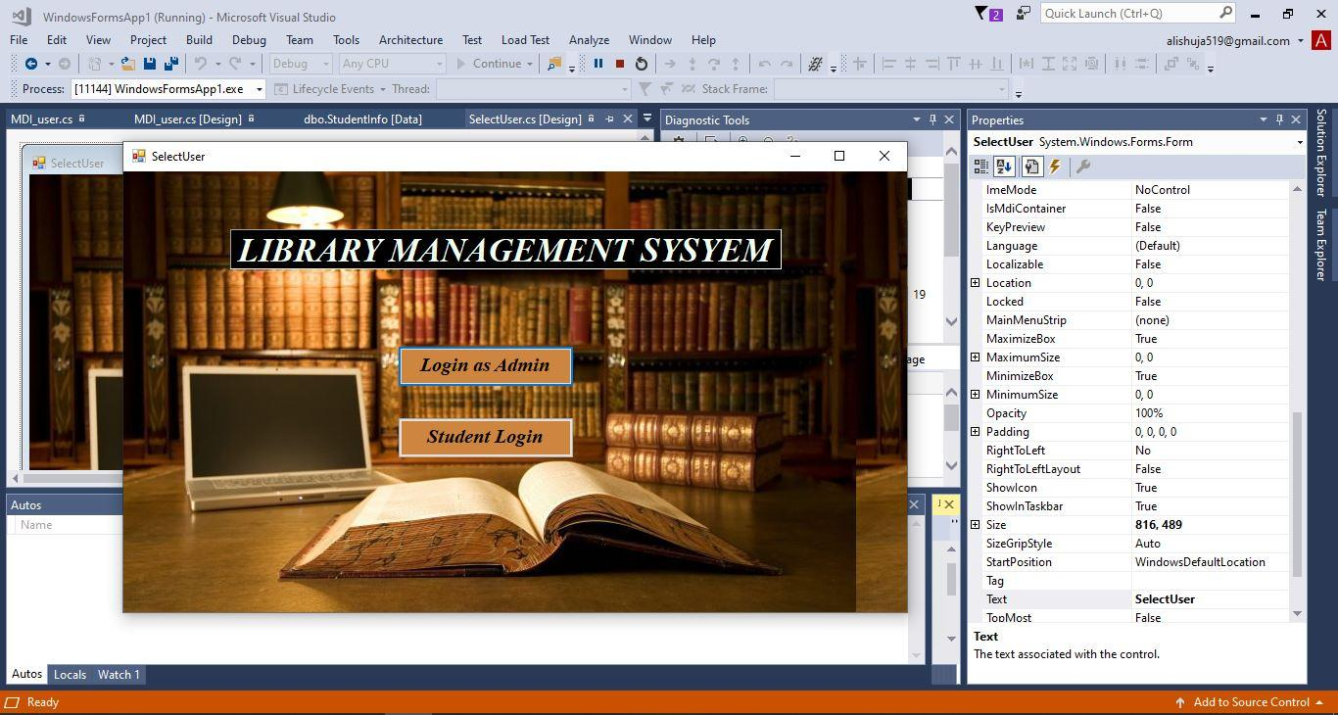

* **Admin Library/Student Library Form:**

After the login successful, For admin login admin library form will appear and for student login, student library form will appear from this form we can access all other forms.

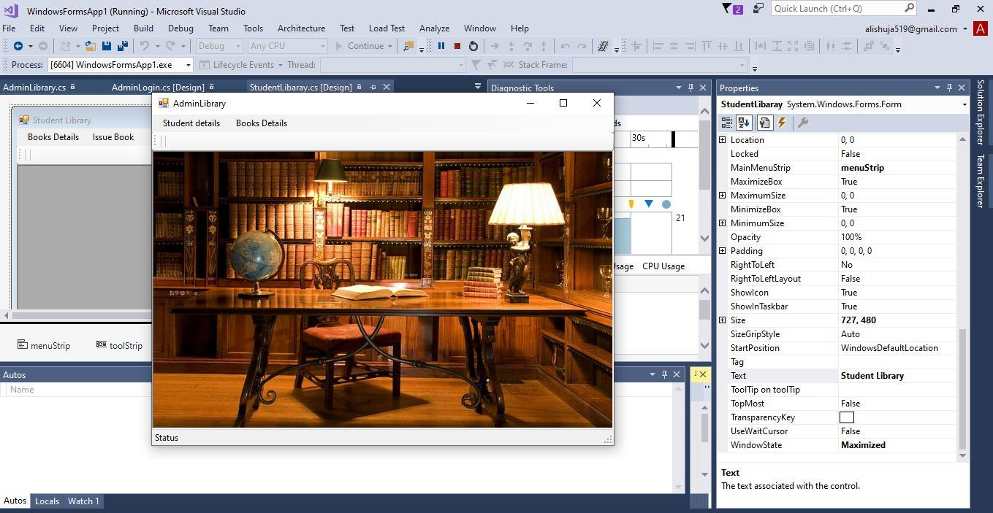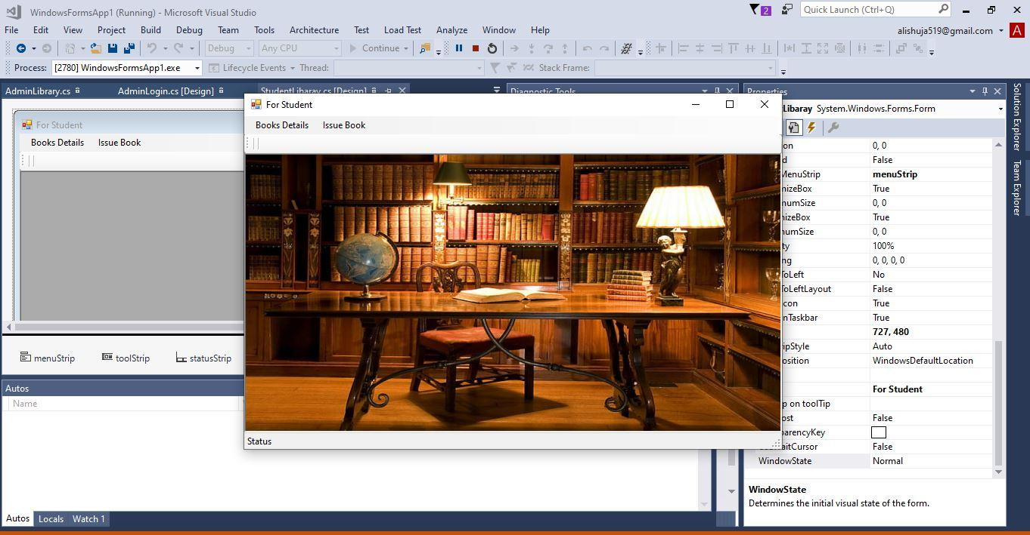

**Student Library Form Admin Library Form**

* **Admin/Student Login:**

Admin can log in with his username or password but for the student login, the student must have to register first then they are able to access the library system.

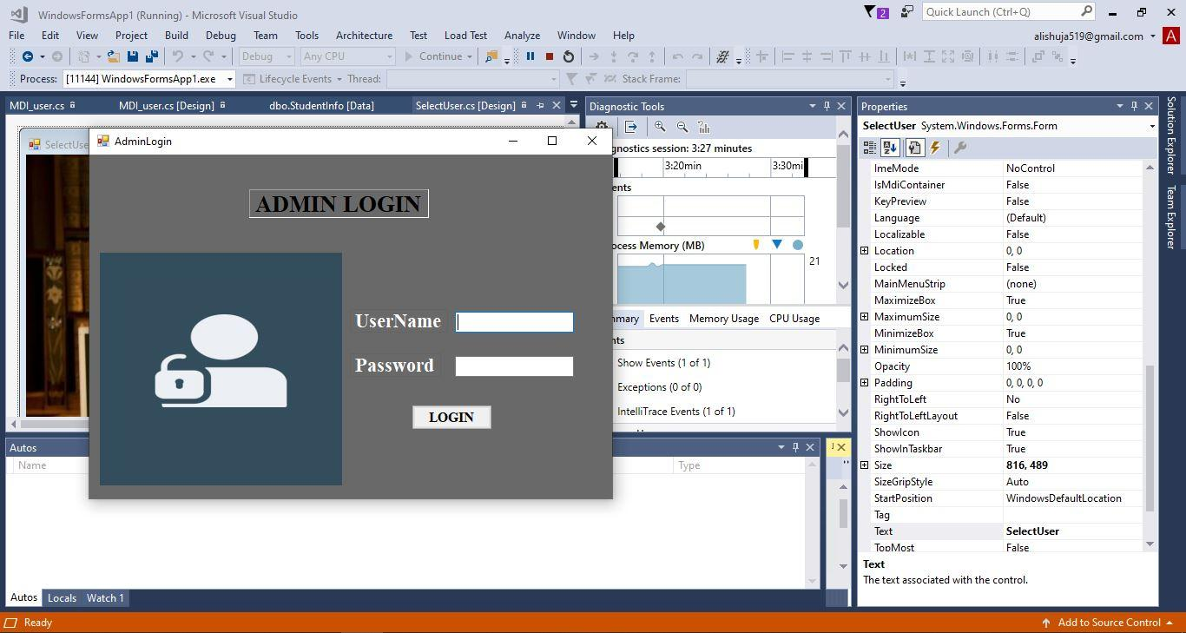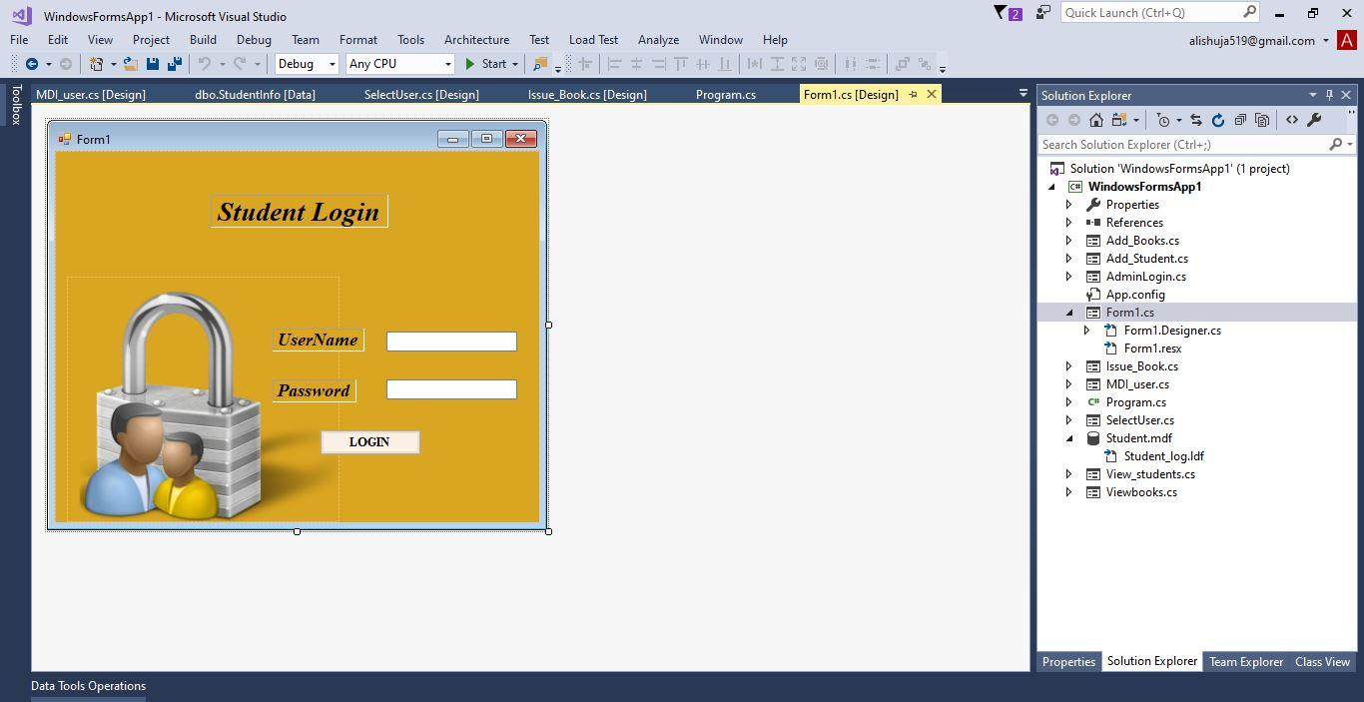

* **Add Book:**

From here you can add the new books to the library shelf.

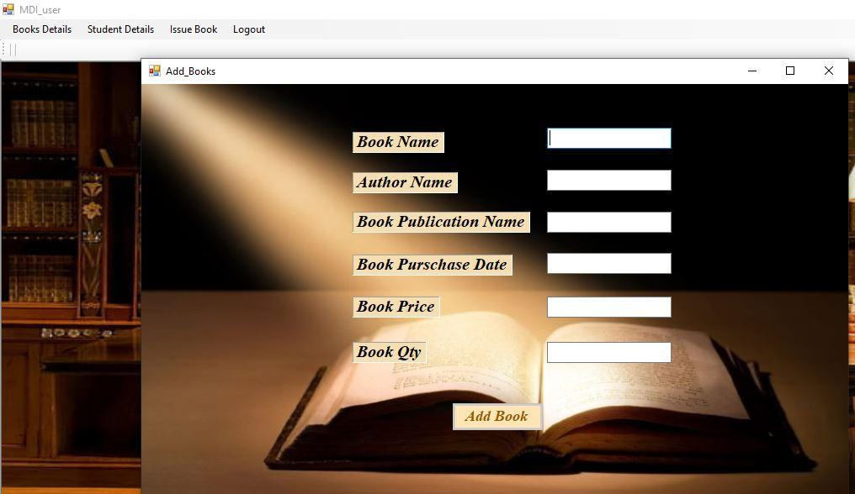

* **View All Books:**

You can view all the books in this form, so it very convenient for the students to check whether the book is available or not, plus you can search a book by book name or by author name.

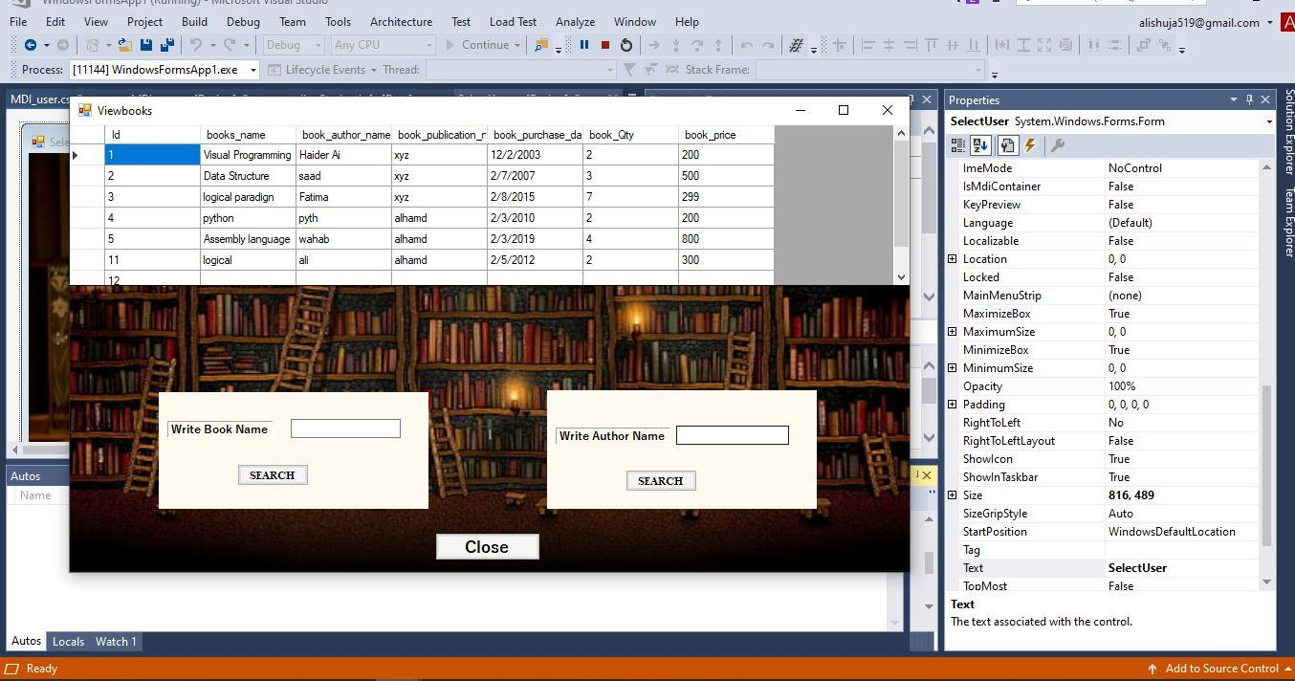

* **Add Student:**

After being added as a student, the student can have his username or password so they can easily get access to this system.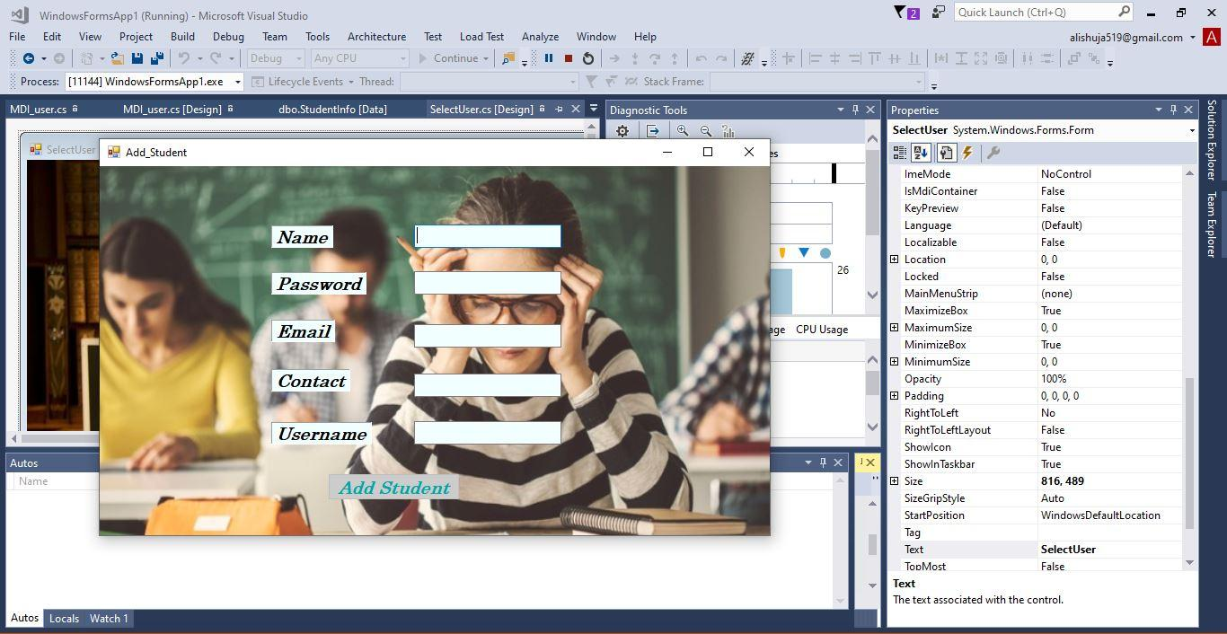

* **View All Students:**

You can view all the students. It shows how many students are using this system, plus you can view the student information by searching their name.

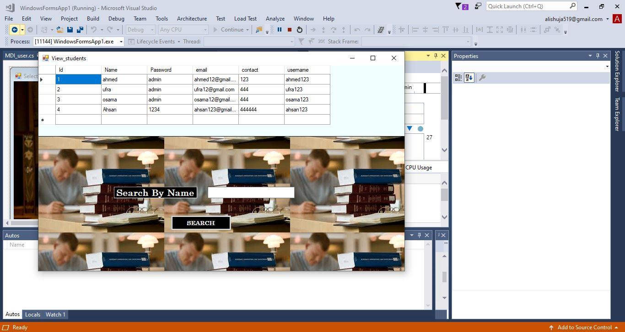

* **Issue Books:**

Form here the students after being registered in the library can issue a book 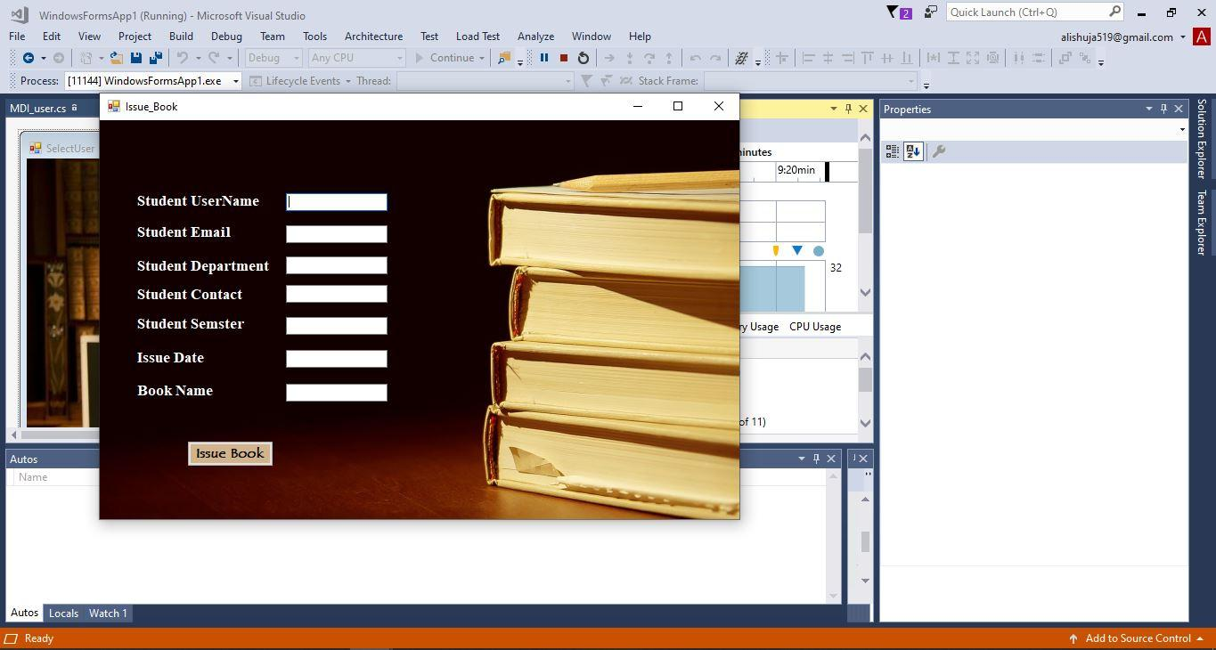

# **System testing:**

The main purpose of the system testing process was the identification of all project defects.

**Testing admin Login form:**

This form is used for admin login. In this login, we enter the username and password. If the username or password is correct, we move to other forms where admin can add books, students, and view books and all students and if anything gets wrong, it will be redirected to the login page and ask again for a password and username. Admin can add the new book details and view all the books on the library shelf and it can also add the new student and view all students information.

**Testing Student Login form:**

This form is used for Student login. In this login, we enter the username and password. If the username or password is correct, we move to another form where a student can view books, issue books and if anything gets wrong, it will redirect to the login page and ask again for password and username. Students can view all book details and issue the book in the library shelf.

**Integration Testing:**

During this type of testing, when supplying the data, we test the functionality of the project framework. The main goal is to check the interfaces of the framework to guarantee that no bugs exist when one module invokes the other.

# **Summary:**

The desire to make life simpler and process quicker has led to different processes being computer-based. Digital technology has changed too many sectors, especially the education sector, in no small measure. In an attempt to promote technology-driven education, a Library Management System has been created to control all library tasks.

# **Conclusion:**

In conclusion, it can safely be concluded that the program is an effective, functional, and reliable library management system through careful review and evaluation of the planned system. It works properly and adequately fulfills the minimum expectations initially set for it. The new system is expected to bring benefits for users and staff in terms of efficiency in the use of library systems